# TOUCH DIMMER SWITCH CIRCUIT USING ARDUINO

**A MINOR PROJECT REPORT**

## CHAPTER 1

**INTRODUCTION**

A Tilt Sensor or a Tilt Switch is a component that detects orientation of an object. One of the best examples for the application of a tilt sensor is its use in aircrafts.

The horizontal and vertical orientation or inclination of the airplane will be provided by the tilt sensor to on board computers. This information is provided to the pilot for safe travelling. There are different types of tilt sensors based on the axes it can measure. A simple tilt sensor is basically a switch that will turn ON or OFF based angle or orientation of the sensor. Such sensor is useful for single axis tilt detection.

In this project, we are **interfacing Mercury switch / Tilt sensor with Arduino UNO.** We are controlling a LED and buzzer according to the output of the tilt sensor. Whenever we tilt the sensor the alarm will be turned on.

## CHAPTER 2

**COMPONENTS REQUIRED AND DESCRIPTION**

### COMPONENTS REQUIRED:

The components that are being used in this project are Mercury Switch/ Tilt Sensor, Arduino UNO, Buzzer, LED, Resistor (220 ohm), Breadboard, Connecting wires, PC with Arduino IDE software, Jumper wires

## COMPONENTS DESCRIPTION:

### TILT SENSOR:

This is a Mercury switch based tilt sensor module that gives high at its output pin when tilted. It requires a 5V of DC input. It’s a three-terminal device consist of input, ground, and output. It has a glass tube consist of two electrode and liquid mercury ball. The liquid mercury ball closes and opens the circuit when inclined in a particular direction.

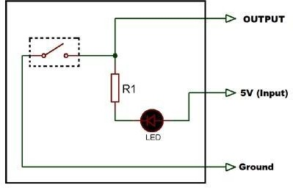

**Fig. 1: Tilt Sensor**

**ARDUINO UNO:**

Arduino is used for building different types of electronic circuit easily using of both a physical programmable circuit board usually microcontroller and piece of code running computer with USB connection between the computer and Arduino. Programming language used in Arduino is just a simplified version of C++ that easily replace thousands of wires with words.

### 

### Fig 2: Arduino UNO

**CHAPTER 3**

**CIRCUIT AND WORKING**

**CIRCUIT DESIGN OF TILT SENSOR:**

To connect a Tilt sensor with the Arduino, it requires 5v dc input to operate. That 5v is supplied using Arduino UNO and the output of Tilt sensor is taken at PIN 4 of the Arduino. LED is connected with the PIN 2 of the Arduino UNO with 220-ohm resistor to limit the current to a safe value. And, the buzzer is directly connected to the PIN 3 of the Arduino UNO. The Circuit diagram is shown below:

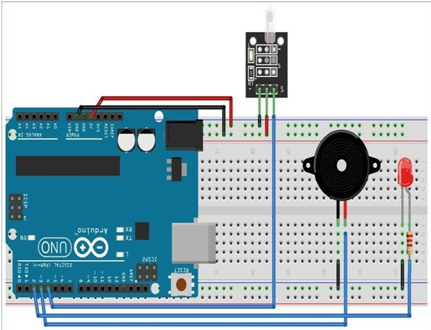

**Fig. 3: Circuit Diagram**

### WORKING OF TILT SENSOR

### Case 1: Not Tilted

Initially, when it is in NOT tilted position as shown in the image below, it gives LOW output because of the liquid mercury complete the circuit by connecting the two electrodes. When the output is LOW on-board LED remain ON.

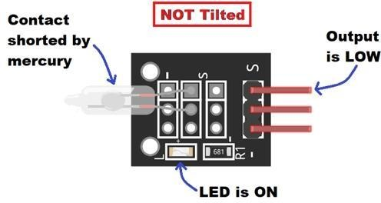

**Fig. 4: Not Tilted Condition**

### Case 2: Tilted

When it is inclined in a particular or angle, the liquid mercury breaks the contact between the metal electrodes and the circuit gets open. Hence, we get HIGH output in this condition and the on board LED turns off.

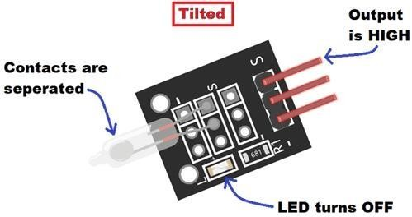

**Fig 5: Tilted Condition**

**WORKING:**

The complete arduino code for interfacing tilt sensor with arduino is given at the end. In the below code, we are defining the pins as input and output. Pin2 and pin3 are set as output pins for LED and buzzer respectively and pin4 is set as input to get input data from the tilt sensor. Now, whenever the tilt sensor inclined beyond the particular angle the output of tilt sensor is high. The output is read through pin4. Therefore, whenever the pin4 is high, it turns ON the LED and buzzer.The execution of the project is shown as flowchart in the fig:2

SET INPUT=4

SET LED=2

SET BUZZER=3

READ FROM TILT SENSOR

INPUT=HIGH

LED=HIGH

BUZZER=HIGH

DELAY=300

LED=LOW

BUZZER=LOW

DELAY=300

**Fig 6:Flow Chart**

**CHAPTER 4**

**OUTPUT**

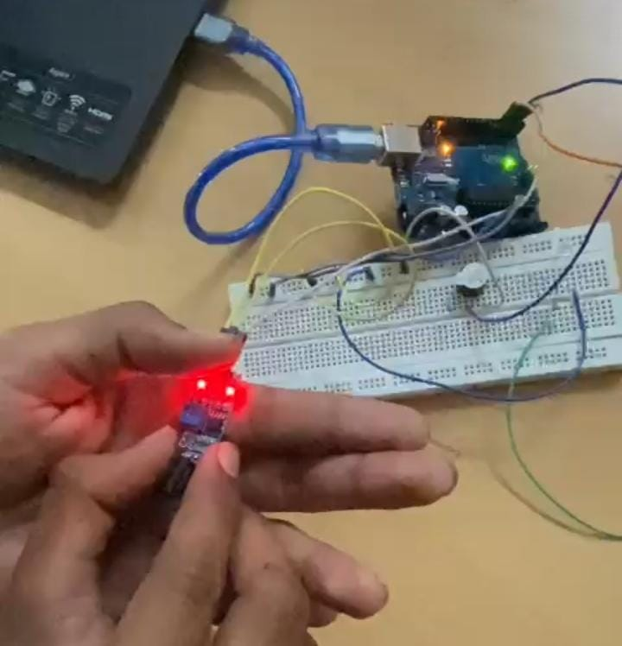

**Fig 7: Not Tilted Position**

When sensor is at Zero degrees.it is known as “Not Tilted Position”, then the buzzer and led are in off condition.

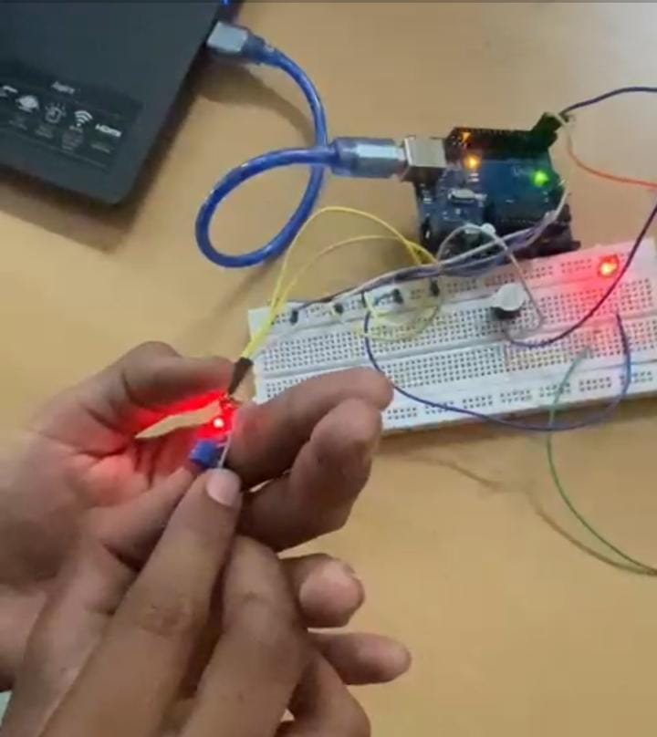

**Fig 8: Tilted position**

When we move more than zero degrees (for ex:one degree),then it is in tilted position. Then the buzzer and led are in on condition.

**CHAPTER 5**

**ADVANTAGES & APPLICATIONS**

**ADVANTAGES:**

1. Cost-effective
2. Low power consumption
3. High resolution and accuracy
4. Very Compact and simple to use

### APPLICATIONS:

1. To monitor the angle at which a mobile phone or tablet held to rotate the auto function.
2. To detect the position of hand-held game systems and in game controller.
3. To indicate the roll of boats, vehicles and aircraft.
4. To measure the angle at which a satellite antenna 'looks' toward a satellite.

## CHAPTER 6

## CONCLUSION

In our project tilt sensor is designed using arduino to detect the orientation of object. Here object on which the sensor placed is breadboard. Hence the sensor detects the orientation of the bread board. If the bread board is tilted more than a threshold angle then the LED glows and the buzzer is on satisfying the objective of our project.

# REFERENCES

1. Bao H, Dong X, Zhao C, Shao LY, Chan CC, Shum P (2010) Temperature-insensitive FBG tilt sensor with a large measurement range. Opt Commun 283:968-970.
2. Deng M, Zhao Y, Yin F, Zhu T (2016) Interferometric fiber-optic tilt sensor exploiting taper and lateral-offset fusing splicing. IEEE Photo Technol Lett 28:2225-2228.

### APPENDIX

### CODE:

void setup()

{

pinMode(2,OUTPUT);

pinMode(3,OUTPUT);

pinMode(4,INPUT);

}

void loop()

{

if(digitalRead(4)==1)

{

digitalWrite(2,HIGH);

digitalWrite(3,HIGH);

delay(300);

digitalWrite(2,LOW);

digitalWrite(3,LOW);

delay(300);

}

}